Table of Contents

Overview 2

Contractor Plugin 2

Accelerator Pack Contractor Management + Contractor Plugin 4

Accelerator Pack Contractor Management 8

**Document Revision History**

|  |  |  |  |  |
| --- | --- | --- | --- | --- |
| **Version** | **Date** | **Status** | **Author** | **Summary of Changes** |
| Version 1 | 05/03/2019 |  | Rohit Gupta |  |

# Overview

This document outlines three different approaches that are used to manage contractors.

* Contractor Plugin
* Accelerator Pack Contractor Management
* Accelerator Pack Contractor Management + Contractor Plugin

## Contractor Plugin

User Interface to manage contractor hierarchy, Contractor Plugin onboarding create and edit Forms. No workflows and triggers are packaged with the plugin

1. On Installation, Identity Provisioning Policies show Contractor forms assignment for create and edit forms. Also, the “Contractor Plugin” application will be created for aggregation of data from Plugin database.

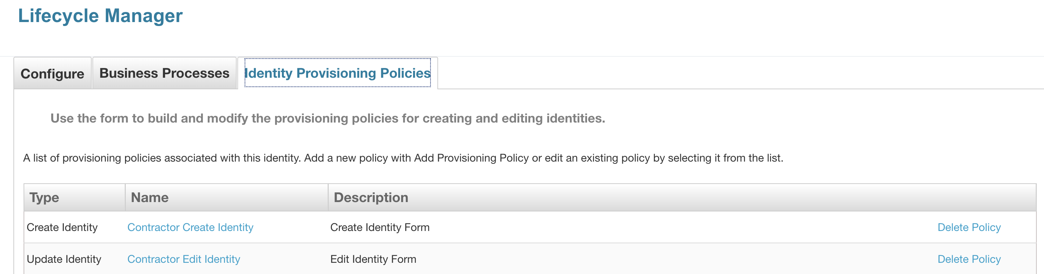

1. Manage Contractor Hierarchy Data
   1. Contractor Agencies
   2. Departments
   3. Assignments (aka Contract)
2. Manages Vendor Contractors and Independent Contractors
3. Create Contractor Form – Contractor hierarchy fields are scoped to Contractor Account Admins and Sponsors. Additional contractor fields can be added to the form. This kicks off contractor onboarding (Joiner process on target applications).

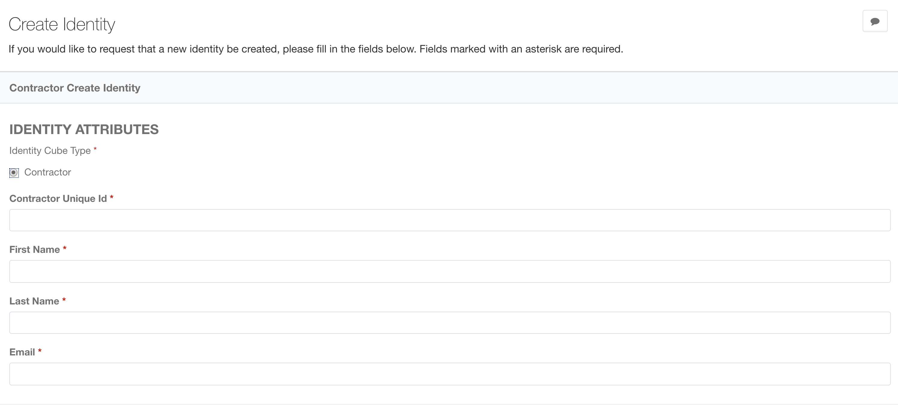

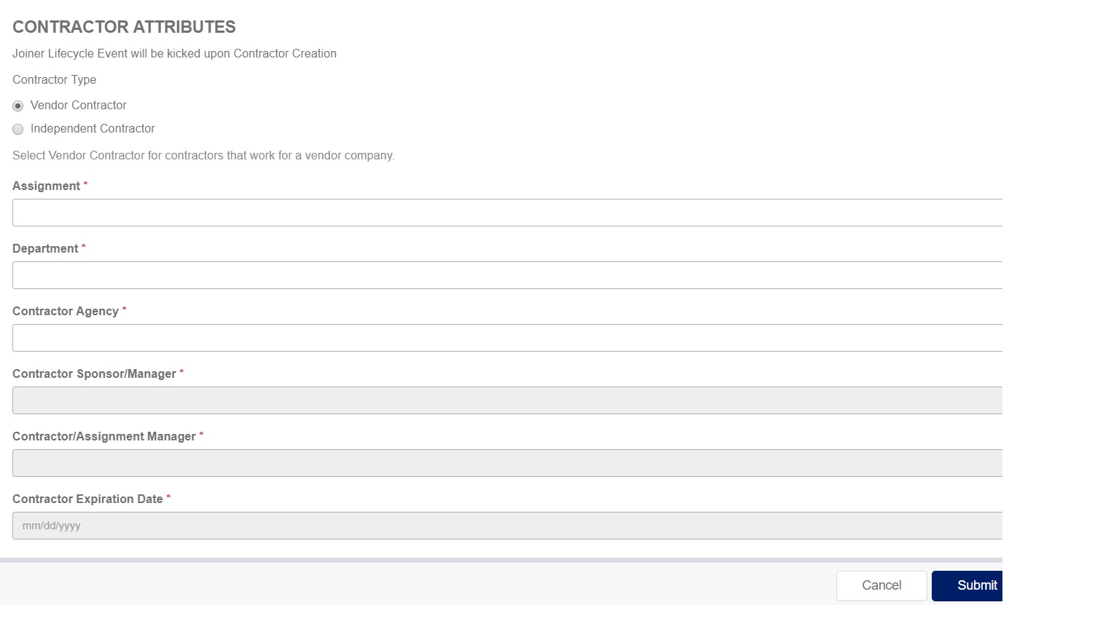

1. Contractor Form – Contractor hierarchy fields are scoped to Contractor Account Admins and Sponsors. Changes done using this form kicks off Attribute Synchronization to target systems (if configured). Additional contractor fields can be added to the form

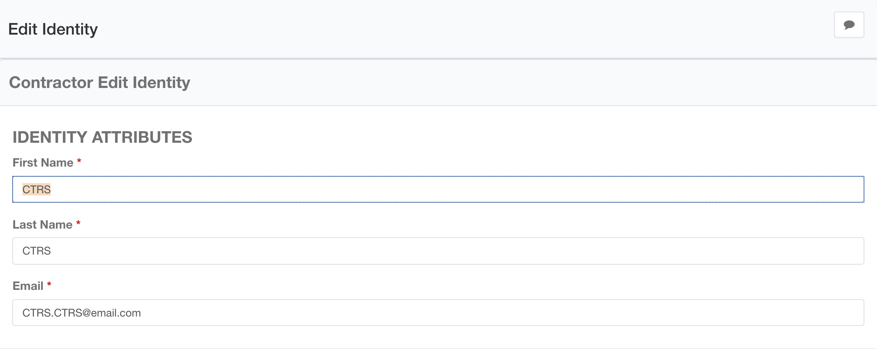

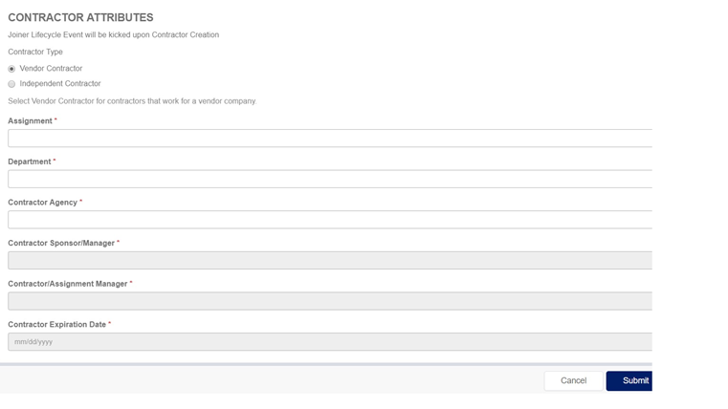

**Note:** No workflows are provided with the plugin. There will be an application “Contractor Plugin” that will need to be aggregated for Contractor Agencies, Departments, and Assignments (Contract) as identity and managed attributes. These managed attributes are used on the forms to populate expiration date from profile and account manager/sponsor scoping.

## Accelerator Pack Contractor Management + Contractor Plugin

Packaged with contractor management workflows and their triggers, Contractor Plugin onboarding create and edit forms

1. On Installation, Identity Provisioning Policies would show Accelerator Pack forms assignment for create and edit forms. Accelerator Pack forms must have precedence over contractor plugin forms. Installation of Contractor Plugin may overwrite this behavior. Import accelerator pack-createidentity.xml and acceleratorpack-editidentity.xml after plugin installation. Also, “Contractor Plugin” application will be created for aggregation of data from Plugin database.

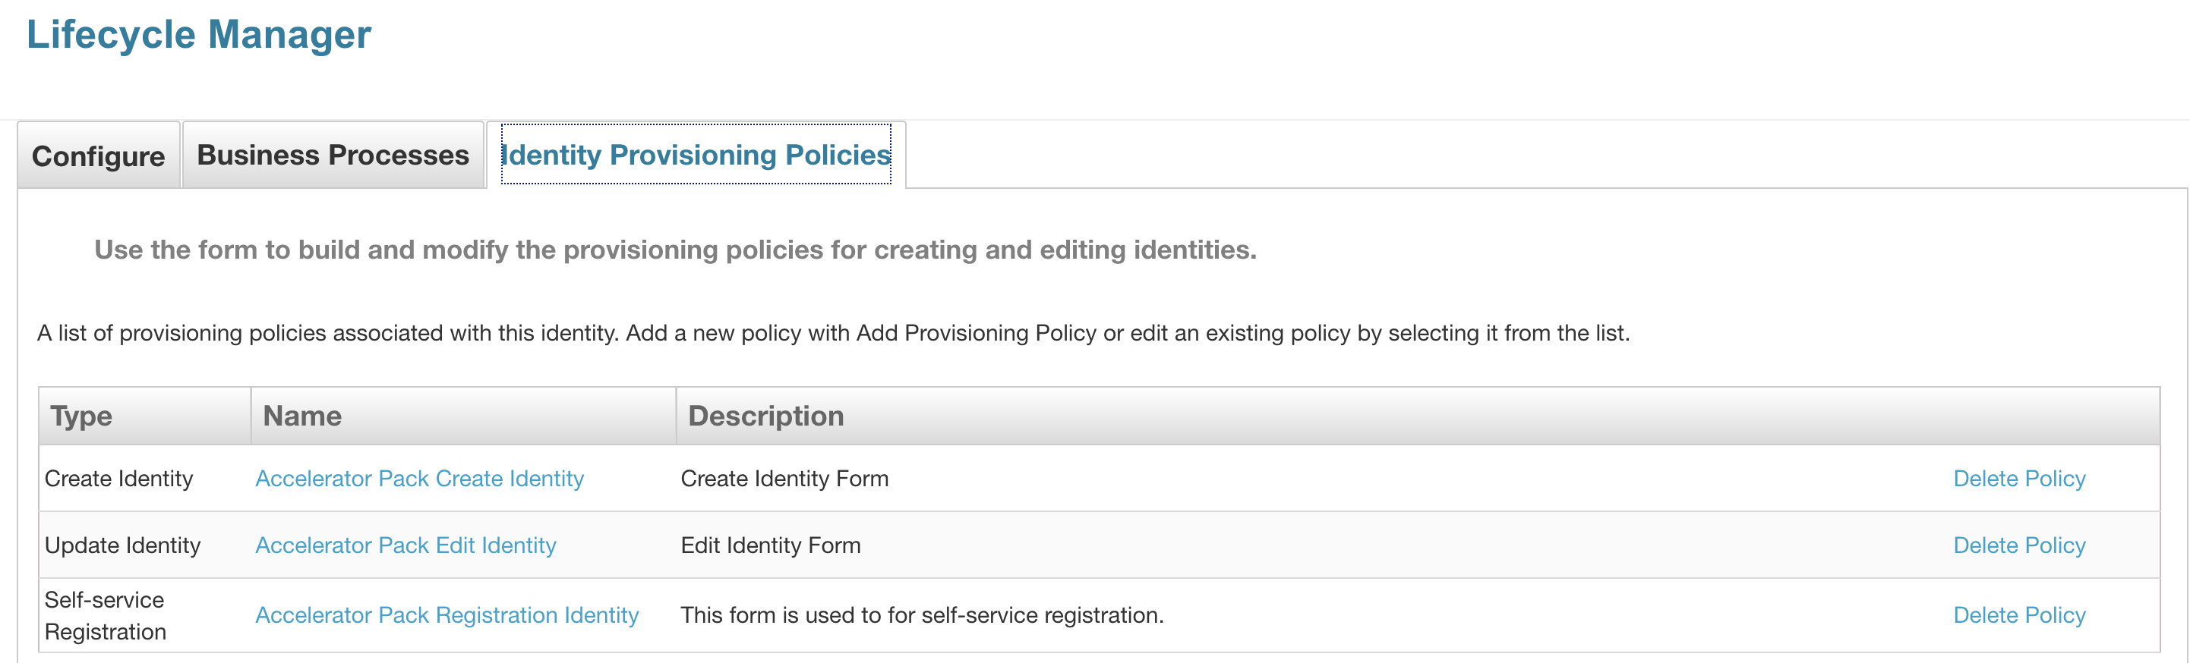

1. Manage Contractor Hierarchy Data
   1. Contractor Agencies
   2. Departments
   3. Assignments (aka Contract)
2. Manage and Synchronize Contractors fields to/from authoritative Contractor Source. A contractor authoritative application can be onboarded to push contractor changes from IdentityIQ / Accelerator Pack to authoritative source (If desired). This can be done by onboarding application using Self Service Onboarding Wizard and checking the “Contractor Repository” option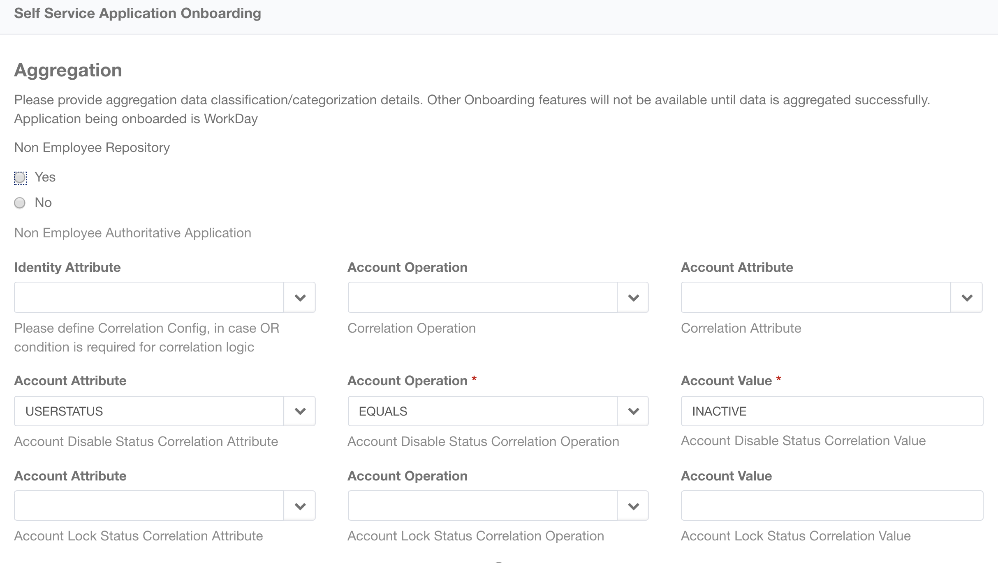
3. Attribute Synchronization of Contractor data from authoritative source to end systems
4. Attribute Synchronization of Contractor data from target systems to authoritative systems
5. IdentityIQ 7.3 user type field is used to tag Contractors
   1. Focused Certifications on Contractors
   2. Reports on Contractors
   3. Policies on Contractors
   4. Advanced Analytics on Contractors
6. Manages Vendor Contractors and Independent Contractors
7. Create Contractor Form – Contractor hierarchy fields are scoped to Contractor Account Admins and Sponsors. Additional contractor fields can be added to the form. This kicks off contractor onboarding aka Joiner process on target applications.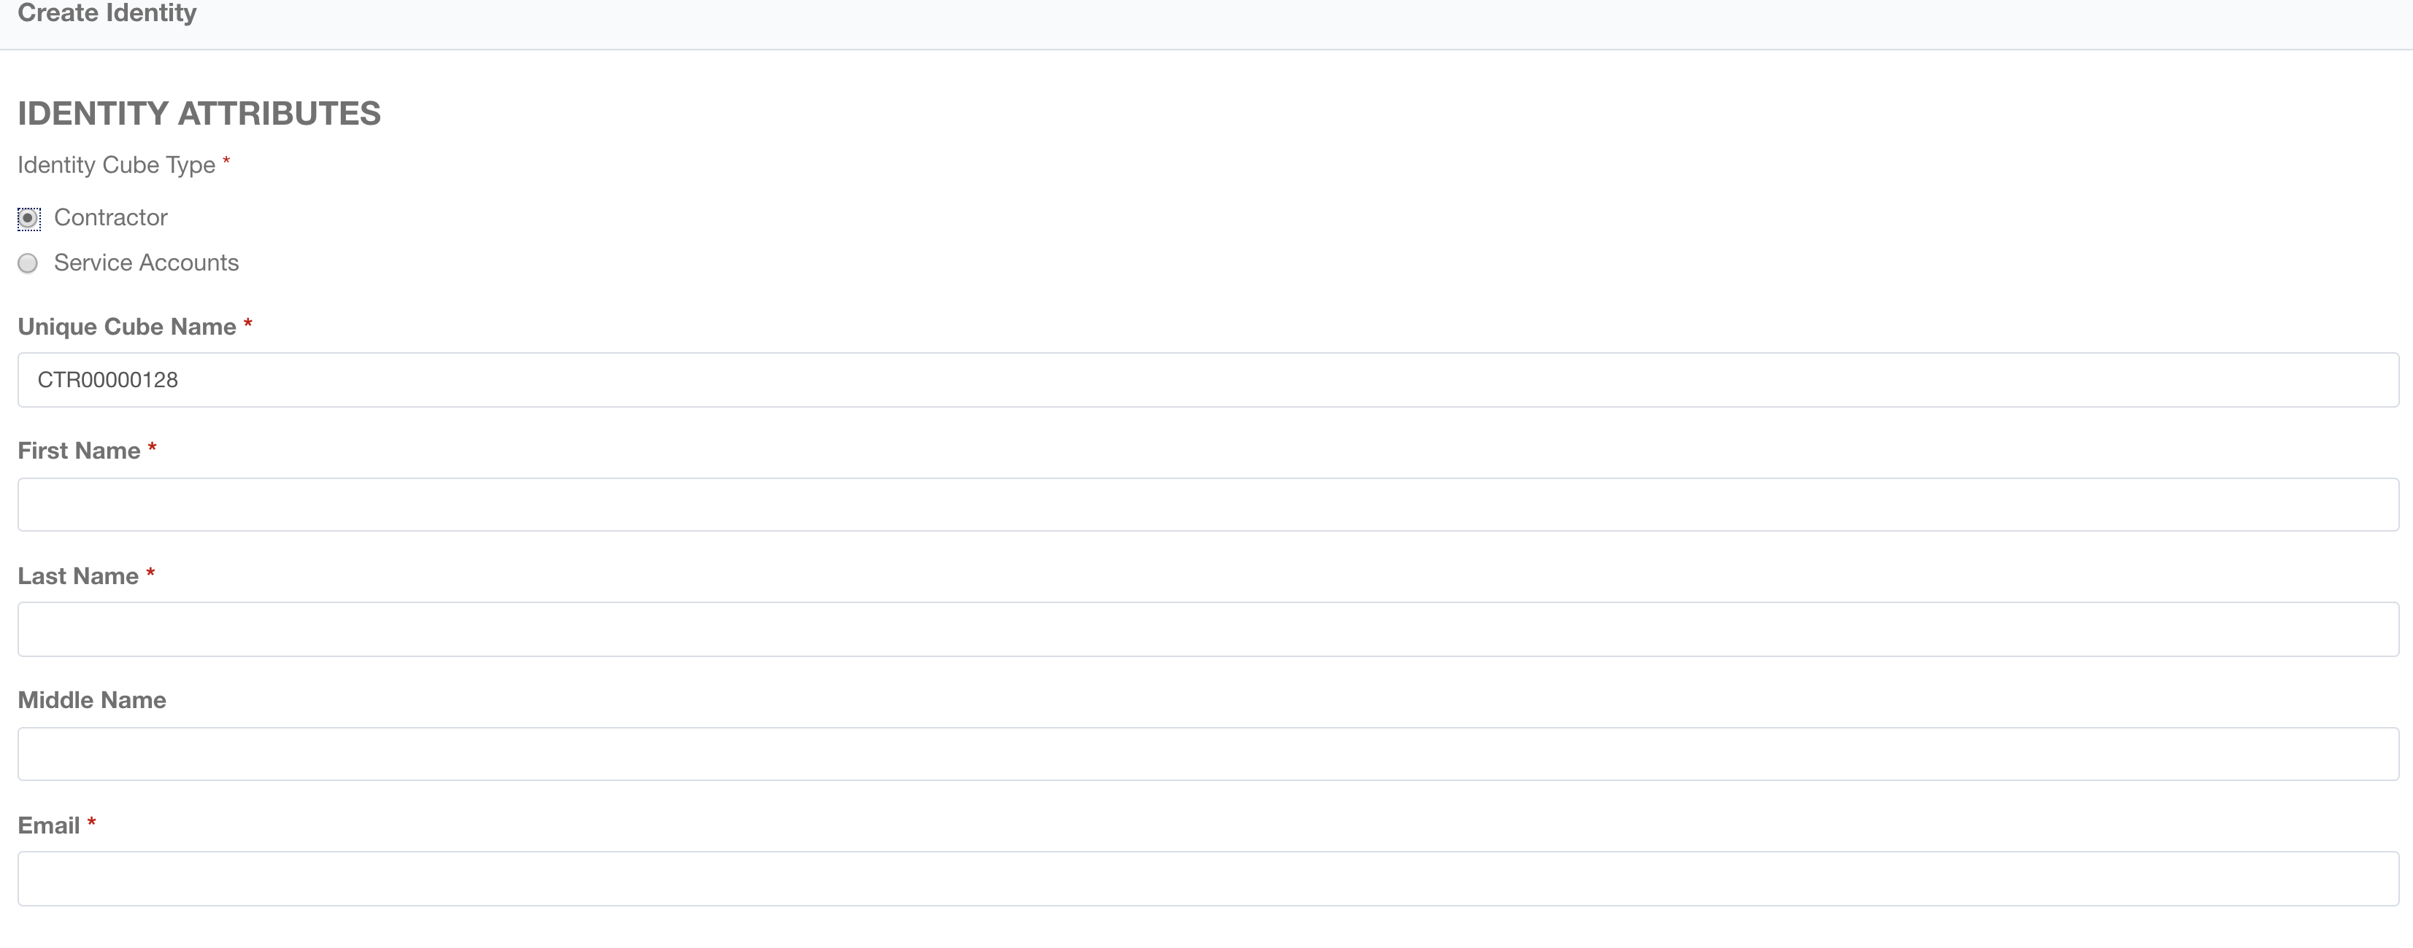



1. Edit Contractor Form – Contractor hierarchy fields are scoped to Contractor Account Admins and Sponsors. Changes done using this form kick off Attribute Synchronization to target systems (if configured). Additional contractor fields can be added to the form.

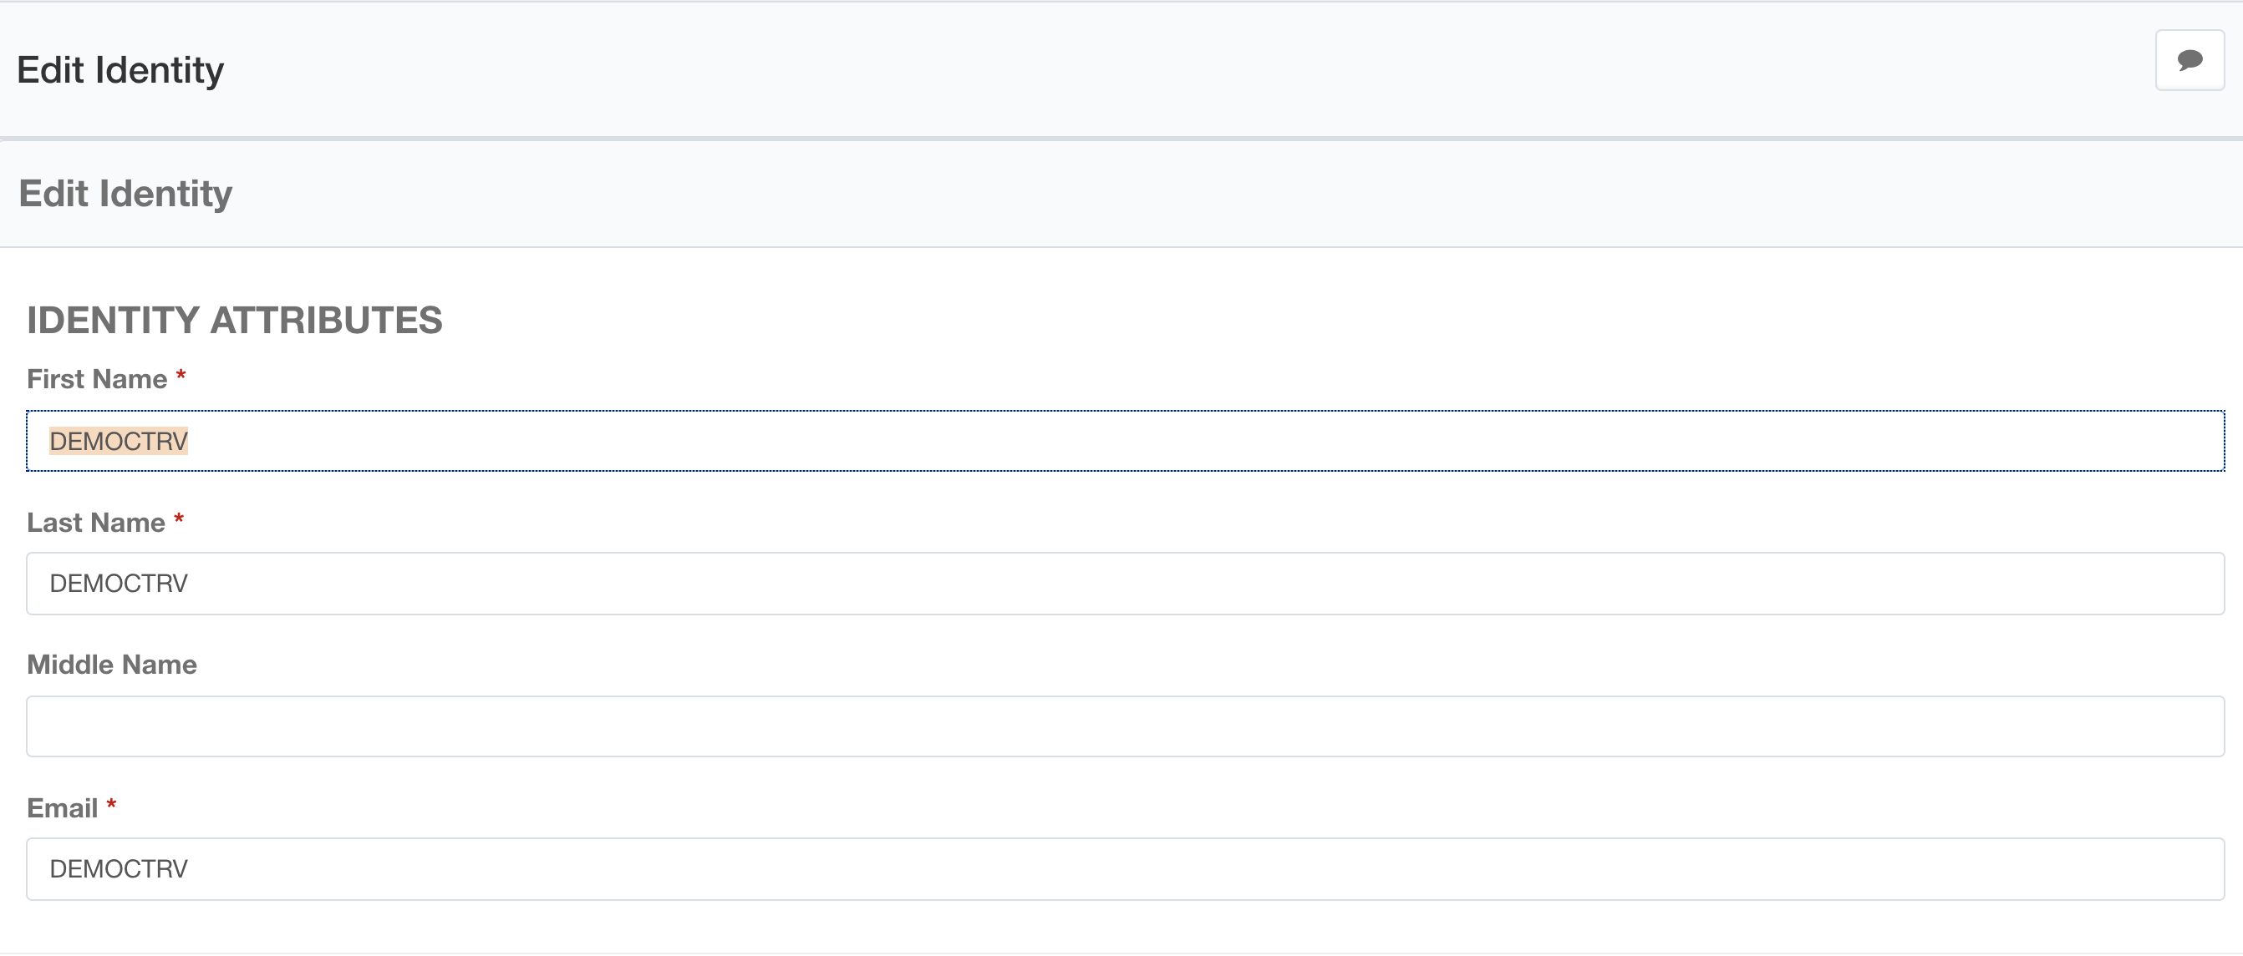



1. Joiner Workflow
   1. Joiner Trigger on Contract Assignment
   2. Email To Contractor Sponsor/Manager Approval (Optional)
      1. Approval can be auto-approved if requestor and approver is same
   3. Birthright Account and Access
   4. Email To Contractor Sponsor/Manager
   5. Email To Contractor/Assignment Manager
2. Rehire Workflow
   1. Rehire Trigger on Contract Assignment
   2. Employee to Contractors and Contractors to Employees conversion
   3. Email To Contractor Sponsor/Manager
   4. Email To Contractor/Assignment Manager
3. Mover Trigger

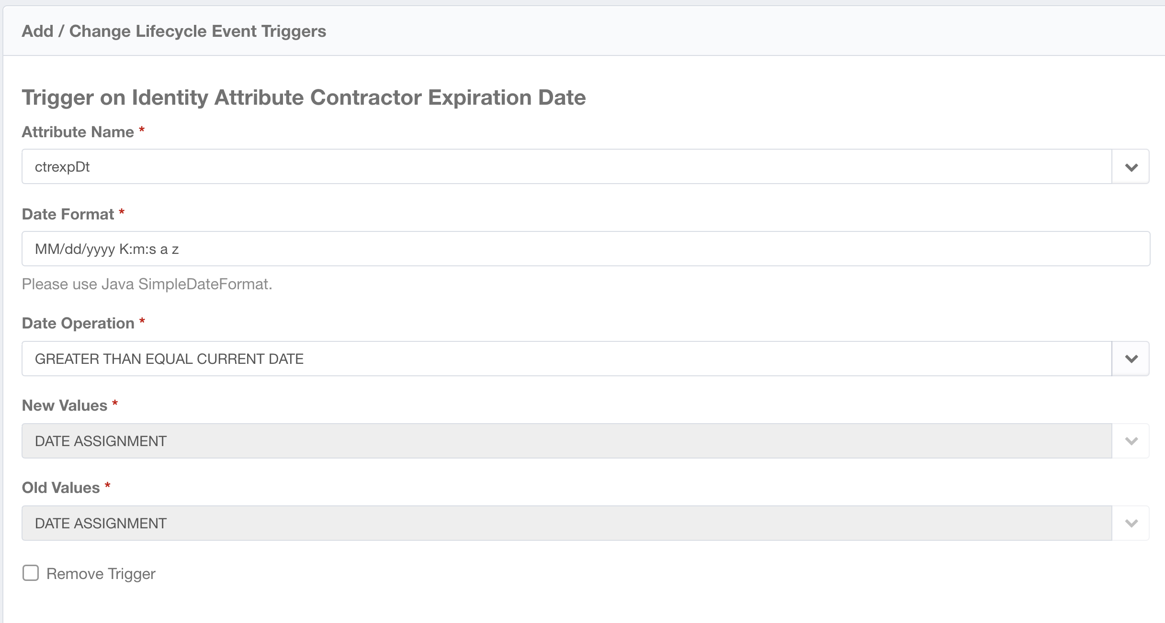

1. Mover Workflow
   1. Mover Trigger on Contract Renewal
   2. Email To Contractor Sponsor/Manager
   3. Contractor Sponsor/Manager Certification
2. Leaver Trigger

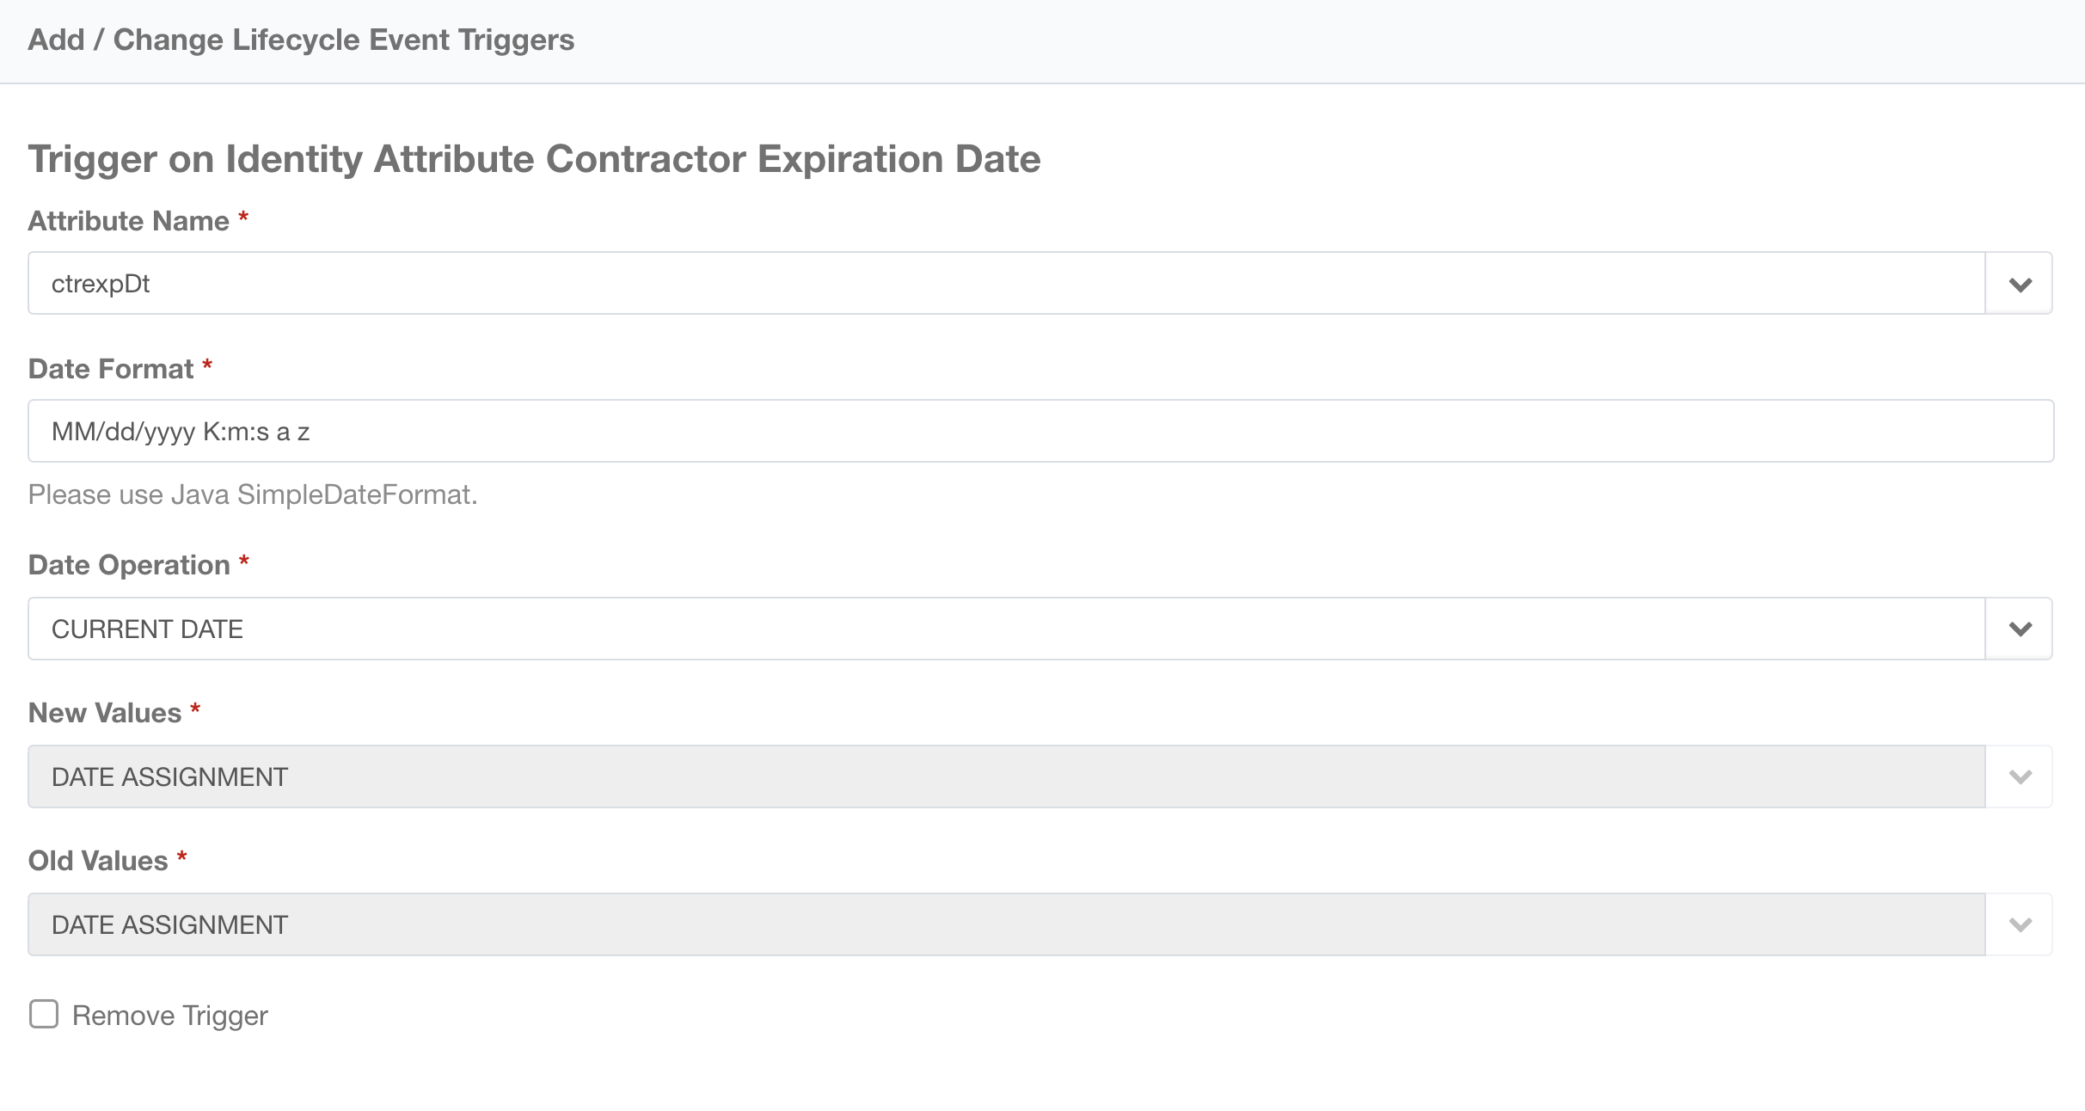

1. Leaver Workflow
   1. Leaver Trigger on Contract Expiration
   2. Shut down Access and Accounts on Contract Expiration Date
   3. Email To Contractor Sponsor/Manager
   4. Email To Contractor/Assignment Manager
2. Attribute Sync Workflow
   1. Synchronize Contractor Attributes
   2. Email To Contractor Sponsor/Manager (Optional)
   3. Email To Contractor/Assignment Manager (Optional)
3. Access Request Workflow
   1. Request Submission Email To Requestor and Requestee
      1. Requestor and Requestee can be Contractor or Contractor Sponsor/Manager or Contractor/Assignment Manager
   2. Approval Email To Contractor Sponsor/Manager
   3. Approvals by Contractor Sponsor/Manager
   4. Request Completion Email To Requestor and Requestee
      1. Requestor and Requestee can be Contractor or Contractor Sponsor/Manager or Contractor/Assignment Manager

**Note:** There will be an application “Contractor Plugin” that will need to be aggregated for Contractor Agencies, Departments, and Assignments (Contract) as identity and managed attributes as identity and managed attributes. These managed attributes are used on the forms to populate expiration date from profile and account manager/sponsor scoping.

## Accelerator Pack Contractor Management

User Interface to manage contractor hierarchy, Accelerator Pack contractor onboarding create and edit forms, and contractor management workflows and their triggers

1. On Installation, Identity Provisioning Policies show Accelerator Pack forms assignment for create and edit forms



1. Manage and Synchronize Contractors fields to/from authoritative Contractor Source. A contractor authoritative application can be onboarded to push contractor changes from IdentityIQ / Accelerator Pack to authoritative source (If desired). This can be done by onboarding application using Self Service Onboarding Wizard and checking the “Contractor Repository” option.

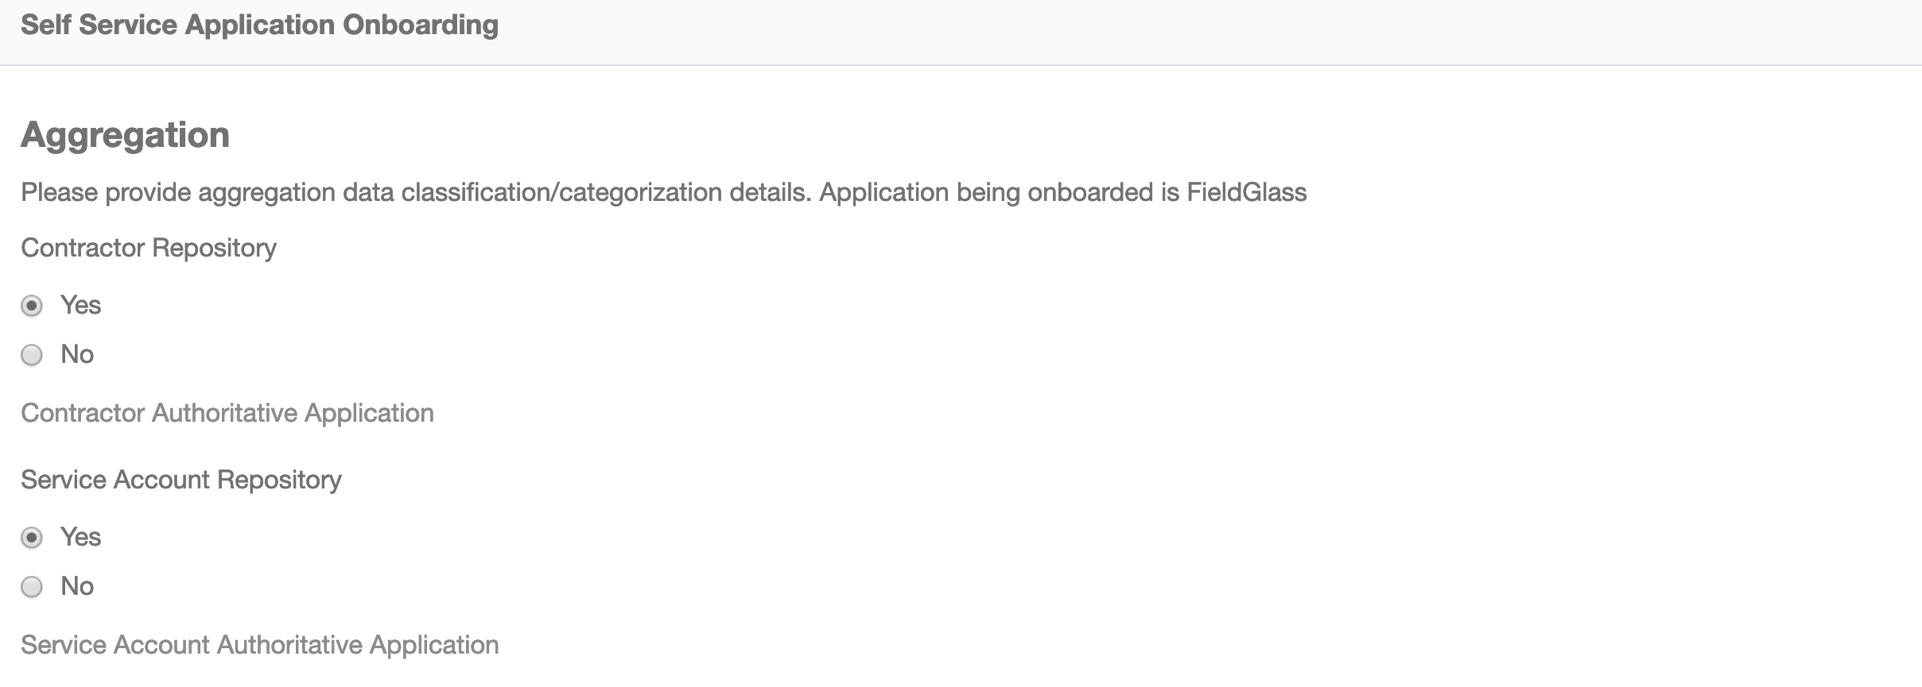

1. Manages All Types of Contractors
2. Attribute Synchronization of Contractor data from authoritative source to end systems
3. Attribute Synchronization of Contractor data from target systems to authoritative systems
4. IdentityIQ 7.3 user type field is used to tag Contractors
   1. Focused Certifications on Contractors
   2. Reports on Contractors
   3. Policies on Contractors
   4. Advanced Analytics on Contractors
5. Create Contractor Form. Additional contractor fields can be added to the form. This kicks off contractor onboarding (Joiner process) on target applications 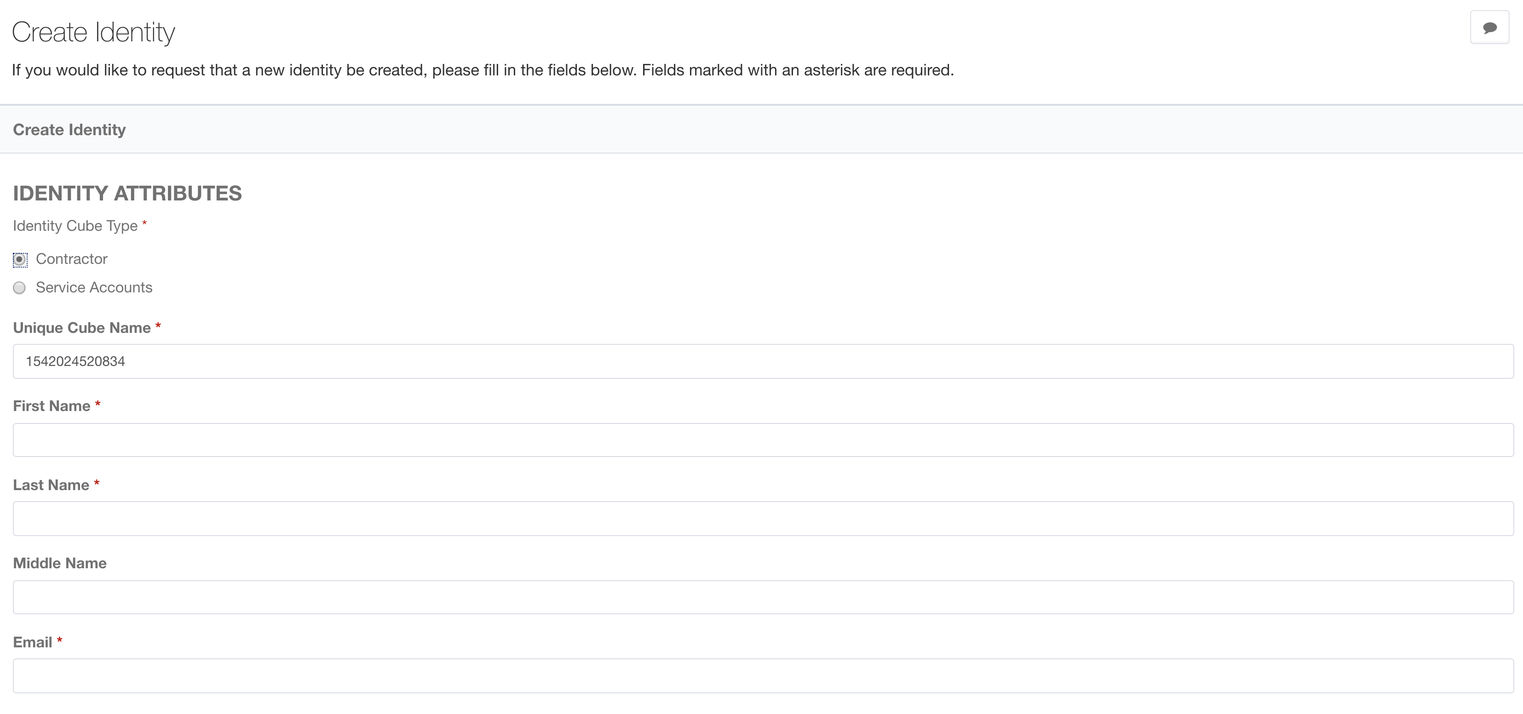

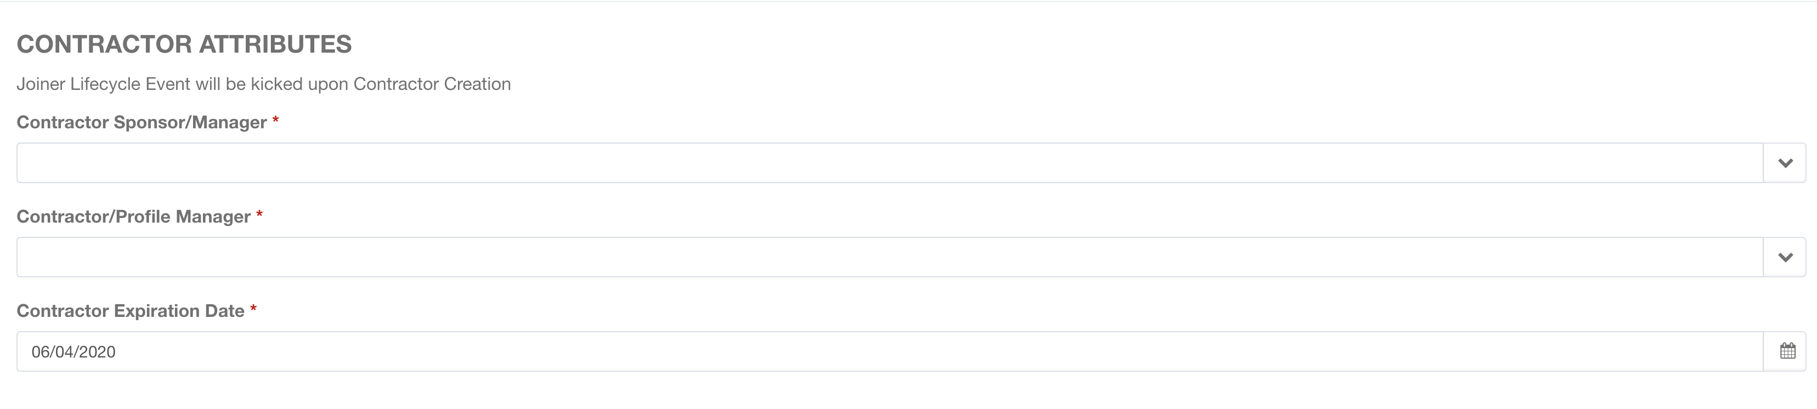

1. Edit Contractor Form. Additional contractor fields can be added to the form. This kicks off attribute sycnhronization process on the target systems (if configured)

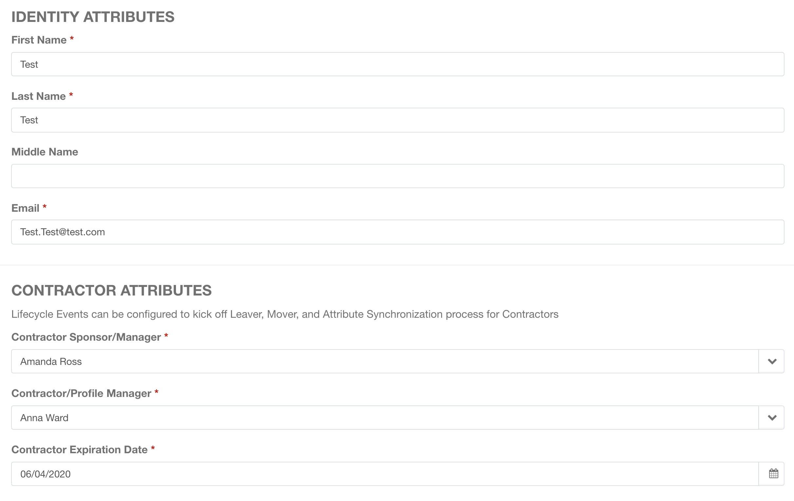

1. Joiner Workflow
   1. Email To Contractor Sponsor/Manager Approval (Optional)
      1. Approval can be auto-approved if requestor and approver is same
   2. Joiner Trigger on Contract Assignment
   3. Birthright Account and Access
   4. Email To Contractor Sponsor/Manager
   5. Email To Contractor/Assignment Manager
2. Rehire Workflow
   1. Rehire Trigger on Contract Assignment
   2. Employee to Contractors and Contractors to Employees conversion
   3. Email To Contractor Sponsor/Manager
   4. Email To Contractor/Assignment Manager
3. Mover Trigger



1. Mover Workflow
   1. Mover Trigger on Contract Renewal
   2. Email To Contractor Sponsor/Manager
   3. Contractor Sponsor/Manager Certification
2. Leaver Trigger



1. Leaver Workflow
   1. Leaver Trigger on Contract Expiration
   2. Shut down Access and Accounts on Contract Expiration Date
   3. Email To Contractor Sponsor/Manager
   4. Email To Contractor/Assignment Manager
2. Attribute Sync Workflow
   1. Synchronize Contractor Attributes
   2. Email To Contractor Sponsor/Manager (Optional)
   3. Email To Contractor/Assignment Manager (Optional)
3. Access Request Workflow
   1. Request Submission Email To Requestor and Requestee
      1. Requestor and Requestee can be Contractor or Contractor Sponsor/Manager or Contractor/Assignment Manager
   2. Approval Email To Contractor Sponsor/Manager
   3. Approvals by Contractor Sponsor/Manager
   4. Request Completion Email To Requestor and Requestee
      1. Requestor and Requestee can be Contractor or Contractor Sponsor/Manager or Contractor/Assignment Manager